

fee study for PROPOSED
MUNICIPAL WATER RATE INCREASES

tranquillity irrigation district

October 15, 2025

PREPARED FOR:

Tranquillity Irrigation District

P.O. Box 487, Tranquillity, CA 93668

PREPARED BY:

PROVOST & PRITCHARD CONSULTING GROUP

455 W. FIR AVE, CLOVIS, CALIFORNIA 93611


REPORT SUMMARY

The Tranquillity Irrigation District (District) has historically funded its municipal water service through monthly charges and land-based assessments that supported what are now 342 active connections. When those revenues fell short, the District relied on reserves and income from outside water sales to balance its budget. In October 2019, District landowners approved rate increases to reduce that dependence and move the system toward financial self-sufficiency.

The proposed rate adjustment continues that effort. With all 342 services now metered, the District can—for the first time—measure actual consumption at each connection and align costs based on actual use per customer. At the same time, rising electricity and fuel prices, declining groundwater levels, and general inflation have increased the cost of operation. The proposed rates will provide the revenue needed for the District to continue providing municipal water services to its customers, which includes funding essential maintenance and pumping activities while proportionally distributing costs among customers according to the demands their water use places on the system.

The proposed 2026 rates shown in Table 1 include a fixed monthly rate relative to potential demand (meter size) and a volumetric rate based on actual usage above the average residential 1-inch meter. The 2026 rates are anticipated to increase three percent (3%) per year from 2027 to 2030 up to the proposed maximum rates identified in the table. The District is asking for the approval of up to the proposed maximum rates in Table 1.

Table 1. Current District Charges vs Proposed Monthly Water Rates
Meter Size | Current  Rate | Proposed  2026 Rate | Proposed Maximum Rate
1” | $50.00 | $32.50 | $36.27
2” | $50.00 | $94.55 | $105.50
3” | $50.00 | $330.91 | $369.25
4” | ** | $650.00 | $725.31
Excess Rate*  [$/1,000 gal] | $0.00 | $1.44 | $1.59
*Base rate volumes are 15,000 gallons per month (GPM). Above that amount is subject to the Excess Rate.
** No prior standalone 4” rate was in place; billing occurred at a higher aggregate rate per §5.4

The amount charged by the District in any year can be lower than the maximum, but will not exceed the maximum rate proposed herein unless the District conducts another Proposition 218 process, as described more, below. After providing notice and holding a public hearing pursuant to Proposition 218, and if there is no majority protest to the proposed rates, the District Board of Directors may implement the proposed rates up to the maximum rate identified herein. The proposed rates allow the District to pay its actual operating costs while allocating the cost of service proportionally among customers.

The proposed municipal water rate increase is being conducted in accordance with provisions of Proposition 218, as reflected in Article XIII D, section 6 of the California Constitution and Section 53750 et seq. of the California Government Code. These constitutional and statutory provisions implement Proposition 218, which established mandatory procedures that local agencies must follow in order to levy certain property related charges or fees.

Pursuant to Proposition 218, once the Board determines the need to increase water charges, the District must evaluate its costs related to providing water to its customers and determine how to allocate the revenue need to landowners who receive the service, in a proportional manner. This Fee Study discusses the services provided by the District, analyzes its revenue needs to provide those services, then allocates those costs among customers that receive those services, in a proportional manner, through the proposed increased municipal water rate.

Following the acceptance of this Fee Study by the Board of Directors, the District will mail a notice to customers regarding the proposed municipal water rate increase. The District’s Board of Directors will hold a public hearing to determine whether or not there is a majority protest against these proposed maximum rate increases. If there is not a majority protest, then the Board of Directors may increase the municipal water rates up to the maximum amount identified on the notice and in this Fee Study.

PURPOSE OF THE REPORT

General
In November 1996, the California voters approved Proposition 218, the “Right to Vote on Taxes Act”, which added Article XIII D to the California Constitution. Proposition 218 (Article XIII D, section 6) imposes certain requirements relative to the imposition of any new or increasing any existing property-related fees and charges by local agencies.

Proposition 218 Requirements
In general, before a local agency can levy new or increased water rates, the following procedures are required:
- Noticing Requirement – The District must mail a notice of the proposed rate increases to all affected property owners or ratepayers. The notice must specify the amount of the fee, the basis upon which it was calculated, the reason for the fee, and the date/time/location of the public rate hearing at which the proposed rates will be considered.
- Public Hearing – The District must hold a public hearing prior to adopting the proposed rate increases. The public hearing must be held not less than 45 days after the required notices are mailed.
- Rate increases subject to Majority Protest – At the public hearing, the proposed rate increases are subject to majority protest. If more than 50% (50% plus one) of the affected property owners or ratepayers submit written protests against the proposed rate increases, the increases cannot be adopted.

Limitations of the Fee Study
This report is limited to the proposed increase to municipal water rates to fully fund the District’s cost of providing municipal water to its customers. The District is seeking to adjust its rates because meters have been installed on all of the 342 municipal water service connections. This enables the District to record connection-specific consumption data and allocate costs based on actual demand per connection, and does not reflect an increase in the budgeted expenses of the District (excluding inflationary increases). Furthermore, the study is limited to the data available at the time the report was prepared.

Revenue Objectives
The District’s primary revenue objective is to fully fund the cost of providing water to its 342 active connections while proportionally allocating each customer’s share of costs with their actual demand on the system. With all services now metered, the rate structure can shift from uniform flat charges to charges based on actual use.

Background

Municipal Water Supply
The District supplies all municipal water from local groundwater [1]. Unlike agricultural customers, who primarily receive surface water deliveries [2], the municipal system is sourced entirely from several District-owned wells. Water is chlorinated, treated for Iron and Manganese removal, and stored in a 500,000-gallon steel reservoir near Colorado Road and W. Silviera Avenue, which provides operational storage and maintains pressure during peak demand periods. The well network and storage tank form a self-contained system sized to meet the community’s daily requirements.

Consumer Information
Tranquillity’s population has held steady at about 770 residents over the past decade, and its domestic water use has followed suit (Figure 1). Like most municipalities, water usage has a strong seasonal trend as most of the water is consumed by landscaping. A 2002 rate study found that roughly two-thirds of the District’s municipal water is consumed for landscaping.
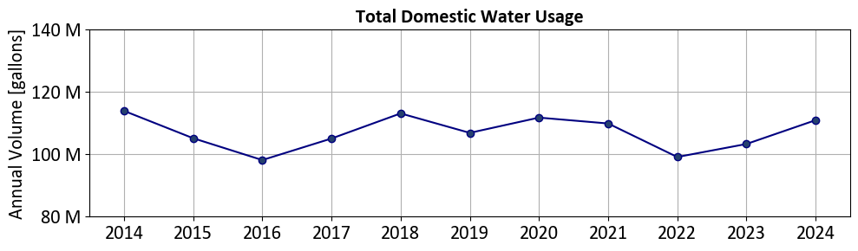
Figure 1. Annual domestic water demand has remained steady for the decade.

2019 Municipal Rate Study
The District last conducted a Proposition 218 public hearing for municipal water rates on December 19, 2019. The proposed rate adjustments were subject to the majority protest process, and the number of written protests received did not exceed the threshold required to constitute a majority protest. The primary purpose of the 2019 rate adjustment was to ensure that the water enterprise could operate on a financially self-sustaining basis. Revenues were increased through a uniform monthly charge per connection, as most services were not metered at the time.

Water Meters
The District was awarded a Proposition 68 Drinking Water Construction Grant (project number 1010030-006C) that funded the installation of water meters for the entire municipal system. Badger brand ultrasonic meters and encoders were installed for each residence with an existing service line, along with meter boxes for properties that did not have an existing box (equipment and software to monitor these meters were also funded). This project was completed in January 2025, providing the community with a complete database of usage per connection to better monitor and manage its water supply (Figure 5 in Appendix). At the time of this report, seven (7) full months of data were available to analyze (February-August), capturing times of minimum usage (February) and peak water usage (July), allowing the rest of the year to be extrapolated and compared to nearby small municipalities.

Table 2. Total number and character of 342 domestic connections within TID
Meter Size | Residential | Commercial/Industrial | School
1” | 263 | 17 | 2
2” | 44 | 7 | 5
3” | 0 | 1 | 1
4” | 0 | 0 | 2
Total | 307 | 25 | 10

Revenue Requirement Analysis

General
The purpose of the revenue requirement analysis is to “determine the adequate and appropriate funding of the utility”. Table 1 summarizes the proposed 2026 rates to generate enough revenue to meet annual expenses of providing municipal water service to District customers. Unlike the agricultural budget, where drought and surface-water availability drive volatility, the domestic system’s finances are steady. Its major costs are wages, electricity for pumping groundwater, groundwater monitoring, and routine maintenance. With no major capital projects, new debt, or population growth expected in the next five years, future rate adjustments will reflect an assumed inflationary increase of 3% (excluding reserve contributions). Table 3 itemizes the budgetary needs to maintain the District’s water system in 2026 at $270,950, and the max rate was set using the 3% inflation to 2030 to $301,883.

Table 3. Projected 2026 Expenses Related to the District’s Domestic Water System
 | 2026 Total Budget  (Ag & Muni) | Municipal Expenses
General Expenses: | Budget | % | Cost
Wages | $1,029,000 | 5 | $51,450
Payroll Taxes & UI | $15,000 | 5 | $750
Medical, Dental, Vision Insurance | $355,000 | 5 | $17,750
Pension Expense (TID cont) | $140,000 | 5 | $7,000
R/M Irrigation System (inc. meter repair) | $20,000 | 0 | $0
Weed Control | $35,000 | 0 | $0
R/M Pumps & Wells | $40,000 | 0 | $0
R/M Vehicles | $35,000 | 5 | $1,750
R/M Equipment | $100,000 | 5 | $5,000
R/M City Water System | $40,000 | 100 | $40,000
R/M Office Equipment | $5,000 | 5 | $250
R/M Building | $5,000 | 5 | $250
R/M Park | $1,000 | 100 | $1,000
Equipment Rental (excavator/heavy equip) | $30,000 | 0 | $0
Contract Water Costs/SLDMWA pu fees | $100,000 | 0 | $0
Contract Water Delivery Costs | $220,248 | 0 | $0
Solar Power | $400,000 | 0 | $0
Irrigation Power - Electrical & Diesel | $300,000 | 0 | $0
Utilities - Office, Shop, Park | $30,000 | 100 | $30,000
City Water Power | $55,000 | 100 | $55,000
Telephone & Broadband | $20,000 | 0 | $0
Office Supplies | $15,000 | 0 | $0
Outside Supplies (shop parts & misc items) | $75,000 | 5 | $3,750
Misc Operating/Office Expenses | $15,000 | 0 | $0
Copier Lease | $5,000 | 0 | $0
SGMA - Central Delta Mendota GSA | $60,000 | 0 | $0
Legal | $55,000 | 0 | $0
Audit Fees | $30,000 | 0 | $0
Gen, Liab, Property Insurance | $60,000 | 0 | $0
Workers Comp Insurance | $40,000 | 5 | $2,000
Employee Training | $1,000 | 0 | $0
Employee Conferences/Meetings | $25,000 | 0 | $0
Fuel & Oil | $300,000 | 0 | $0
City Water Treatment & Misc Expense | $20,000 | 100 | $20,000
Water Sampling | $10,000 | 100 | $10,000
Outside Engineering (doesn't include work on big projects) | $50,000 | 0 | $0
KRWA Expenses (incl. dues) | $50,000 | 0 | $0
SLDMWA | $50,000 | 0 | $0
Dues (all other dues) | $150,000 | 0 | $0
Taxes & Permits (prop., Rights Water) | $40,000 | 0 | $0
Reserve Contribution | $585,000 | 4 | $25,000
Totals | $4,611,248 |  | $270,950

Cost-Of-Service Analysis

General
The purpose of the cost of service analysis is to “equitably distribute the revenue requirements between the various customer classes of service served by the utility” [3]. In proportion to the revenue requirement outlined in section 3, cost was distributed as a function of meter size and volume of water used above the allocated base demand.

Seasonality Analysis
The District recorded seven months of metered data after installation, so the remaining months were extrapolated to estimate annual fees. Because summer use in the District rises more sharply than in nearby cities, a composite curve based on surrounding systems would have distorted local patterns. Instead, the analysis fit a curve (Equation 1) directly to the District’s own data—which fortunately captured both the seasonal peak and trough—producing a more representative annual estimate. This curve was then applied to each customer based on their individual seven-month usage record (Figure 2). For seasonal trends at every meter size, see (Figure 7) in the appendix.

Equation 1 . $Usage=\sin{x}-\left(\frac{1}{2\sqrt{3}}*\cos{2x}\right)$

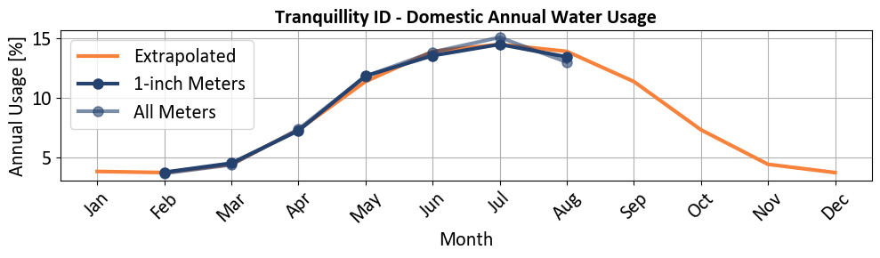
Figure 2. Equation 1 (orange) plotted against all District domestic well usage data.

Equivalent Meter Ratio
The equivalent meter ratio was developed using the Safe Maximum Operating Condition (SMOC) of each meter, which is a standard practice in rate setting. Using this ratio, the size of the meter relative to the base 1-inch meter is used to determine potential demand requirements, i.e. a 2-inch meter has a potential demand that is 2.9 times the potential demand of a 1-inch meter, so the base rate (fixed monthly charge) for a 2-inch meter is 2.9 times that of a 1-inch meter. The ratios for 3-inch and 4-inch meters are 10.2 and 20.0 times the 1-inch rate, respectively. The American Water Works Association (AWWA) does provide lookup tables for meters, but not for the ultrasonic type meters like the Badger Meter installation effort. Therefore, the equivalent meter ratio was developed using the standard methods outlined by AWWA but using the SMOC for each meter.

RAte Design Analysis

General
The purpose of the rate design analysis is to determine “how to recover the appropriate level of costs from each customer class”[3]. To do this, the revenue and equivalent meter ratios will be tested against an ‘excess rate’, a volumetric charge above the base rate volumes.

Volumetric Rates
Each customer’s fixed monthly charge includes a base allotment of 15,000 gallons per month, corresponding to the average monthly use of a typical 1-inch residential connection. Water use above this threshold is classified as “overage” and due to the additional cost of service to provide water beyond the base allotment, is billed at the volumetric rate. The overage rate applies uniformly to all meter sizes and customer classes to ensure that connections using more than the average residential demand contribute proportionally to the additional costs of supply, treatment, and delivery.

Anticipated Invoices by Customer Class
The rate design analysis ensures that each customer’s bill reflects the cost of providing their service. The methods described in Sections 3 and 4 allocate expenses in proportion to the benefit each customer receives. Under the proposed rates, the fraction of overages shown in Table 4 are generally consistent among all customer classes and meter sizes around 15%. However, a small number of outliers produced higher charges under the overage rate. The 2” residential accounts had exceptionally high consumption elevated average values among the customer class.

Table 4. Distribution of revenue by customer class at the maximum proposed rate.
Customer Class | Total Revenue | Average Monthly Bill per Customer | Average Monthly Fixed Rate | Average Monthly Overage Rate | Excess Rate Fraction of Monthly Bill
Residential - 1” | $128,179 | $43.78 | $36.27 | $7.51 | 17%
Residential - 2” | $111,645 | $160.41 | $105.50 | $54.91 | 34%
Commercial - 1” | $7,971 | $41.51 | $36.27 | $5.24 | 13%
Commercial - 2” | $11,588 | $107.30 | $105.50 | $1.80 | 2%
Commercial - 3” | $4,703 | $391.96 | $369.25 | $22.71 | 6%
School – 1” | $3,016 | $41.88 | $36.27 | $5.61 | 13%
School – 2” | $4,249 | $118.04 | $105.50 | $12.54 | 11%
School – 4” | $30,621 | $850.57 | $725.31 | $125.26 | 15%
Total: $301,973

Table 5. Distribution of charges per customer
 | 2026 Proposed Rate |  |  | Maximum Proposed Rate
Customer Class | Minimum | Median | Maximum | Minimum | Median | Maximum
Residential - 1” | $32.50 | $36.11 | $70.26 | $36.27 | $40.25 | $77.97
Residential - 2” | $94.55 | $120.71 | $460.80 | $105.51 | $134.40 | $509.92
Commercial - 1” | $32.50 | $32.50 | $53.99 | $36.27 | $36.27 | $59.99
Commercial - 2” | $94.55 | $94.55 | $103.36 | $105.51 | $105.51 | $115.25
Commercial - 3” | $351.43 | $351.43 | $351.43 | $391.96 | $391.96 | $391.96
School – 1” | $32.50 | $32.50 | $61.82 | $36.27 | $36.27 | $68.65
School – 2” | $94.55 | $94.55 | $128.58 | $105.51 | $105.51 | $143.09
School – 4” | $650.00 | $820.05 | $820.05 | $725.40 | $913.16 | $913.16

School Rate
Tranquillity School District is the only customer served by the two 4-inch connections and is the largest volume water user. In the past, the school district paid a negotiated rate above the base fee to account for its heavier demand. Now, with meter data providing a clear record of the school’s actual consumption, no special rate adjustment is needed.

Comparison of Local Domestic Water Rates
Fixed costs in this fee structure comprise 85% of the revenue generated to maintain the District’s domestic water system. Among small Central Valley municipalities, the District’s rates were already competitive and would remain among the least expensive under the newly proposed rate structure.

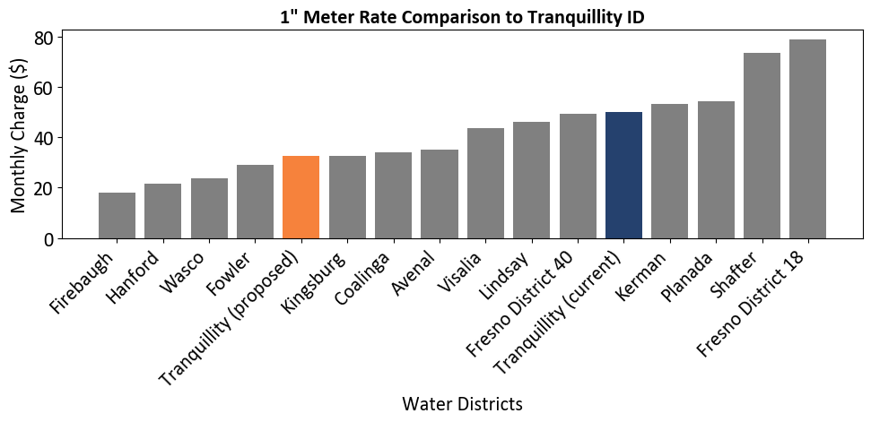
Figure 3. Fixed domestic water rates for 1” meters proposed for 2026 at municipalities near Tranquillity, benchmarked to the District’s current and 2026 proposed rates.

MUNICIPAL Water Rate increase Challenge

GOVERNMENT CODE § 53759
In accordance with Government Code section 53759, any judicial action, challenge, or proceeding related to the establishment or modification of the proposed Municipal Water Rate Increase shall be commenced within 120 days of the effective date of the final adoption of Municipal Water Rate Increase. Pending the results of the protest tabulation, this final adoption is expected by December 31, 2025.

GOVERNMENT CODE §§ 53759.1 AND 53759.2
Assembly Bill (AB) 2257, effective January 1, 2025, codifies Government Code sections 53759.1 and 53759.2. Government Code section 53759.1 authorizes public agencies to implement an exhaustion of administrative remedies requirement in the context of a proposed Proposition 218 property related fee or assessment. If the local agency complies with certain specified requirements, property owners are required to submit a written objection regarding a proposed property related fee or assessment during the ratemaking process and by a specified deadline no less than 45 days after mailing of the notice pursuant to Proposition 218, and prohibited from challenging the property related fee or assessment in litigation if they did not submit a timely written objection. To implement this requirement, the local agency is required, among other things, to prepare written responses to the timely submitted objections and present them to the local agency governing body, which will make certain specified determinations prior to the close of the Proposition 218 protest hearing. This process is intended to run concurrently with the Proposition 218 timeline and does not impact a property owner's ability to submit a protest pursuant to Proposition 218.

Government Code section 53759.2 specifies the scope of a Court's review of the administrative record of the underlying ratemaking proceeding, if the local agency complied with Government Code section 53759.1 in adopting the property related fee or assessment being challenged.

The District intends to comply with and implement Government Code section 53759.1 with respect to the proposed Municipal Water Rate increase. Property owners will be informed of the deadline and process to submit a written objection, and other dates related to the District’s compliance with this provision.

7. Bibliography
[1] Provost and Pritchard, “Tranquillity Irrigation District Water Management Plan,” Fresno, CA, 2011.
[2] Woodard & Curran and Provost & Pritchard, “Groundwater Sustainability Plan for the Northern and Central Delta-Mendota Regions,” Los Banos, CA, 2022.
[3] American Water Works Association, Principles of Water Rates, Fees, and Charges, M1, 7th ed. in Manual of Water Supply Practices. Denver, CO: American Water Works Association, 2017.

APPENDIX - Maps
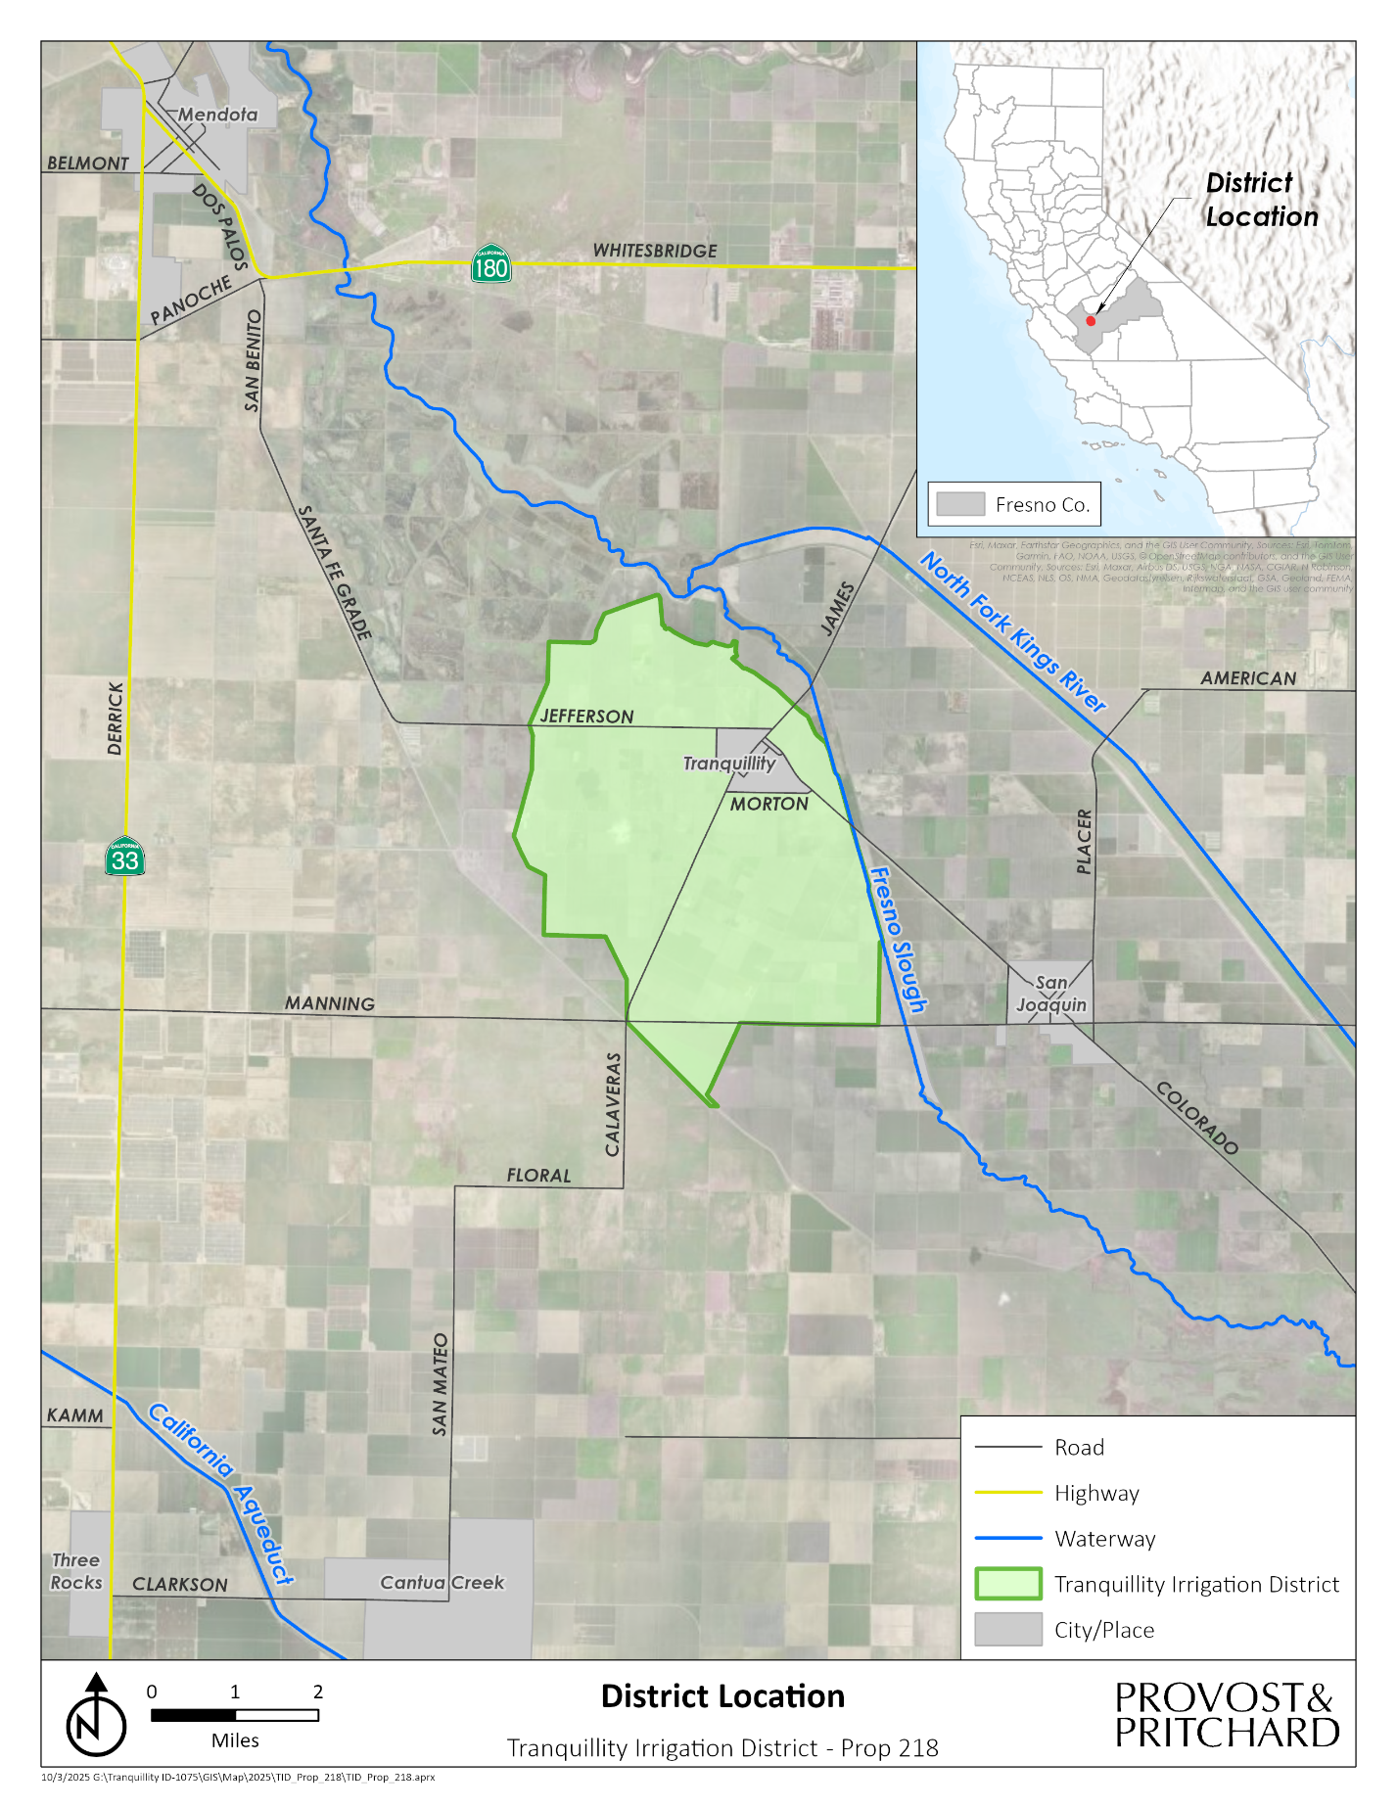
Figure 4. Regional overview of Tranquillity Irrigation District
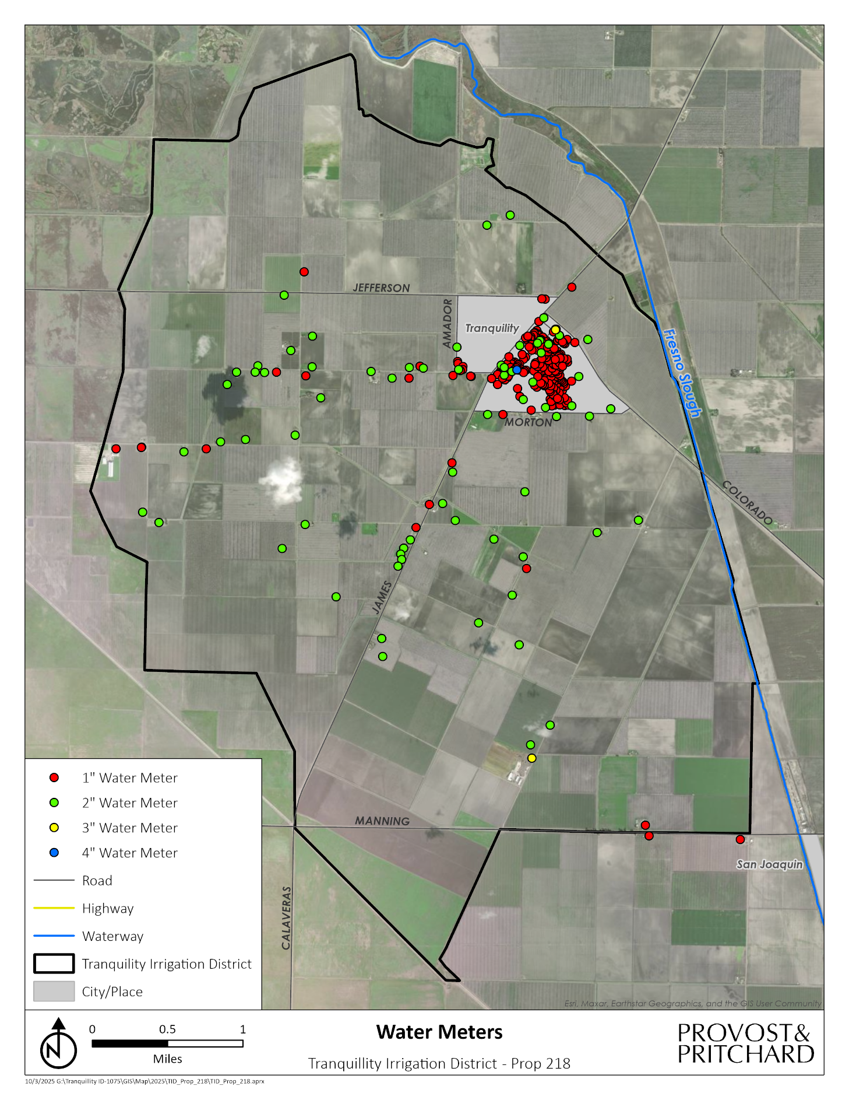
Figure 5. Active municipal connections in Tranquillity Irrigation District

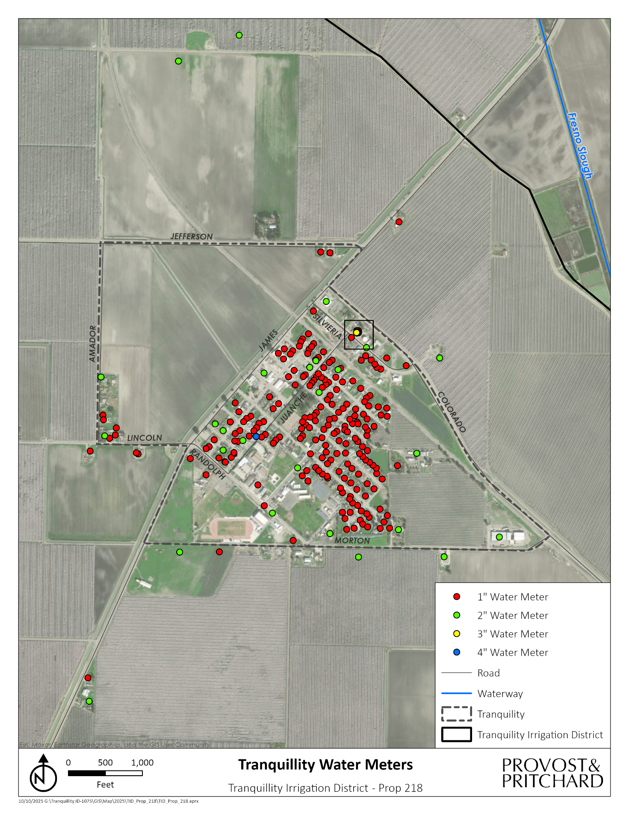
Figure 6. Active municipal connections within the Tranquillity Census Designated Place (CDP)

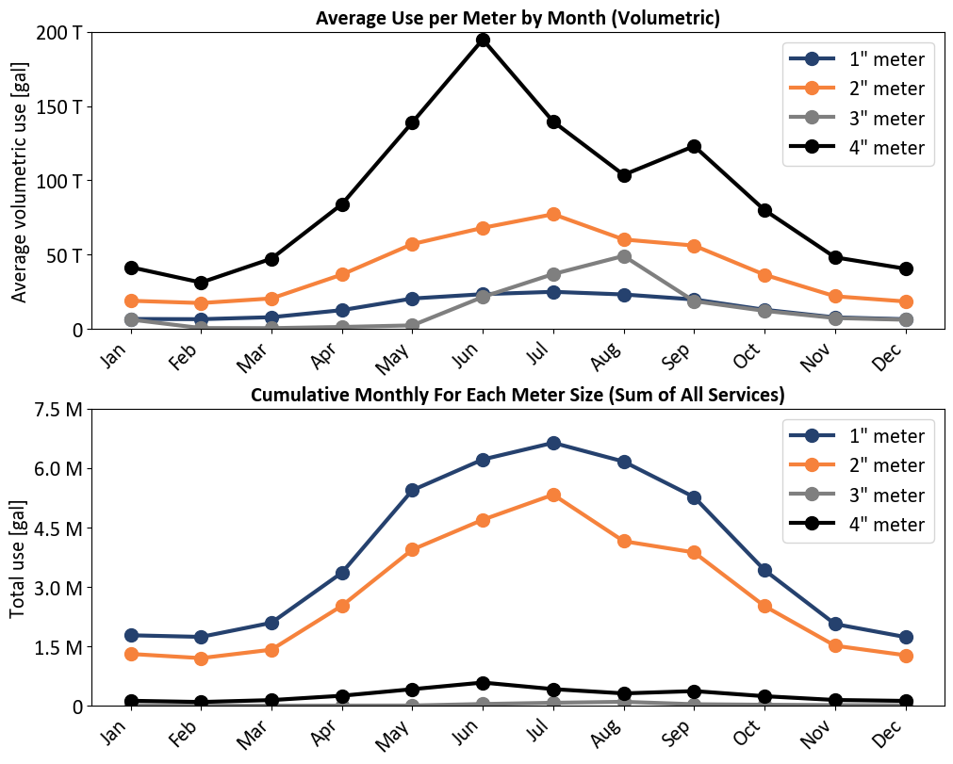
Figure 7. (top) Seasonal water usage average per meter and (bottom) cumulative water use of the system by meter size

3% inflation rate was applied to all expenses unrelated to the $25,000 annual reserve contribution.
Badger Meter E-Series G2 Ultrasonic Meter
Safe Maximum Operating Conditions are 55, 160, 560, and 1,100 gallons per minute for 1”, 2”, 3”, and 4” meters, respectively
One of the school’s 4” meter is the final connection to be installed.

