MINUTES OF THE MEETING OF THE
TRANQUILLITY IRRIGATION DISTRICT BOARD OF DIRECTORS
November 19, 2025
PRESENT: President Jerome F Salvador, Director William Pucheu, General Manager Danny M Wade,
Assistant Manager Rodney D Wade, Engineering Consultant Joe Hopkins, Counsel Lauren Layne & Secretary/Treasurer Liz Reeves
ABSENT: Director George Ayerza Jr
President Salvador called the meeting to order at 8:35 am.

ADDITIONS OR DELETIONS TO AGENDA: None
PUBLIC COMMENTS: Jon Caywood and Giana Olivera were present as observers. A representative from Fresno County was present as well offering services to improve Tranquillity.
MINUTES: The minutes of the meeting of October 15, 2025 were approved on voice count. Director Pucheu motioned for approval and President Salvador seconded the motion.
TREASURER REPORT: The Cash Flow statement was presented for the month of October 2025 including the cash disbursements and receivables. Director Pucheu motioned for approval of the Treasurer report. President Salvador seconded the motion.
WATERMASTER'S REPORTS: Water use — irrigation and drinking water: Watermaster Wade reported on the usage totals for the month of October 2025, along with the well pumping totals and the Mendota pool reporting. The well depths along with PH/TDS readings were presented to the Board. For the reservoir project — 2 gates have been installed and there is % mile left.
DIRECTOR REPORT: none

NEW BUSINESS/ACTION ITEMS: none
COUNSEL REPORT:
KRWA: so far have received 260% of rainfall
SLDMWA: there are favorable updates on litigation
SGMA: discussions are moving forward with SWRCB. We almost have all the signatures needed for the JPA.
ENGINEERING CONSULTANT REPORT:
SGMA: reporting is being done. The Central group will be looking at policies and such that aren't being adhered to. A monitoring well was destroyed and will be removed from the monitoring network. Proiects: no change reported.
MANAGER REPORT:
- 2025 Water Schedule Tracking: the report was presented
- 2025 Revised Schedule: the updated schedule was presented

3. SLWD — Final Payment: this was billed out in November
- Kings River Water: Discussion in closed session.
- Water Banking: discussion in closed session
- Department of Public Planning: Yvette from Fresno County presented some info about the County General Plan.
- Health Benefits — Update TID Employee Handbook: we will be updating the handbook with
ACWA Benefits Policy with regards retirement eligibility for benefits
- TID BBQ - Friday November 21, 2025
CLOSED SESSION:
1. Closed Session Pursuant to California Government Code Section 54956.8

CONFERENCE WITH REAL PROPERTY NEGOTIATORS
Property: Temporary Water Transfer
Agency Negotiator: Danny M Wade & Rodney D Wade
Negotiating Parties: TID & SLWD Under Negotiation: Price & Terms (no reportable action)
2. CONFERENCE WITH REAL PROPERTY NEGOTIATORS Pursuant to California Government Code

Section 54956.8
Property: Water Rights
Agency negotiator: Danny M Wade & Rodney D Wade
Negotiating parties: Various Water Users, unspecified for the benefit of the public agency
Under negotiation: Instruction to negotiator will concern price and terms of payment (no reportable action)

3. CONFERENCE WITH REAL PROPERTY NEGOTIATORS
Government Code Section 54956.8
Property: Kings River Water Rights
Agency negotiator: Danny M Wade & Rodney D Wade
Negotiating parties: Lower River Units of the Kings River Water Association
Under negotiation: Instruction to negotiator will concern price and terms of payment for rental agreement.
(no reportable action)
4. CONFERENCE WITH LEGAL COUNSEL - EXISTING LITIGATION
Closed session pursuant to Paragraph (1) of subdivision (d) of Government Code Section 54956.9.
Name of Case: NRDC v. Jewell — U.S. District Court— Eastern District of Ca!ifornia (Case
No. 1:05-cv-01207UO-EPG)
(no reportable action)

5. CONFERENCE WITH LEGAL COUNSEL - EXISTING LITIGATION
Closed Session pursuant to Government Code Section 54956.9(d)(1)
Name of Case: James Irrigation District v. KRWA, et al. (no reportable action)
6. CONFERENCE WITH LEGAL COUNSEL - POTENTIAL LITIGATION -1 case Closed Session pursuant to Government Code Section 54956.9 (d)(l) (no reportable action)

7. CONFERENCE WITH REAL PROPERTY NEGOTIATORS
Closed Session Pursuant to California Government Code Section 54956.8
Property: Fresno Slough Water District land
Agency Negotiator: Danny M Wade & Rodney D Wade
Negotiating Parties: TID & Angiola WD
Under Negotiation: Price & Terms (no reportable action)

8. CONFERENCE WITH LEGAL COUNSEL - EXISTING LITIGATION
Closed Session pursuant to California Government Code Section 54956.9(d)(1).
Name of case: California Sportfishing Protection Alliance v. All Persons
Interested in the Matter of the Validity of the Northern and Central DeltaMendota Regions Groundwater Sustainability Plan, et al., Stanislaus County
Superior Court, Case No. CV-20-001748 [Delta-Mendota Subbasin SGMA
Challenge]. (no reportable action) ii. Name of case: Center for Biological Diversity, Restore the Delta, and Planning and Conservation League v. United States Bureau of Reclamation, Tranquillity Irrigation District, et al. In the United States District Court for the Eastern
District of California, Case No. 1:20-cv-00706 DAD-EPG. (no reportable action)

9. CONFERENCE WITH LEGAL COUNSEL - EXISTING LITIGATION
Closed Session pursuant to California Government Code Section 54956.9(d)(1).
NORTH COAST RIVERS ALLIANCE, CALIFORNIA SPORTSFISHING PROTECTION ALLIANCE, PACIFIC COAST FEDERATION OF FISHERMEN'S ASSOCIATIONS, SAN FRANCISCO CRAB BOAT OWNERS ASSOCIATION, INC., and INSTITUTE FOR FISHERIES RESOURCES v.
UNITED STATES DEPARTMENT OF THE INTERIOR, et al. - United States District court,
Eastern District of California (Case No. 1:16-CV-307 DAD-SKO). (no reportable action)
Reports out of Closed Session: none
The Board adjourned at 10:35 am.
The next meeting will be held at 8:30 am on December 17, 2025 at the TID office.

 | 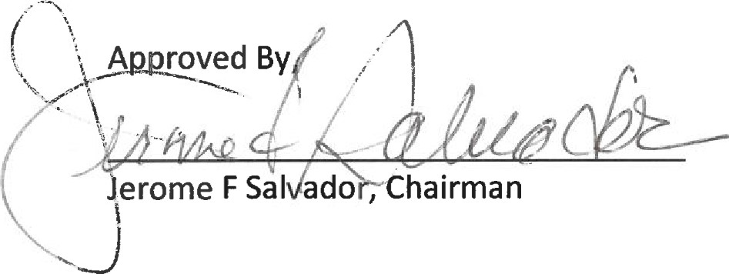
   | Respectfully Submitted,  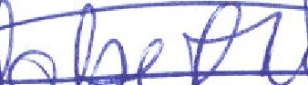 | 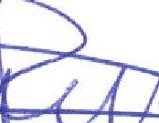
  Eliza | th Reeves, Secretary/Treasurer

