MINUTES OF THE MEETING OF THE

# TRANQUILLITY IRRIGATION DISTRICT BOARD OF DIRECTORS

October 16, 2024

PRESENT: President Jerome F Salvador, Director William Pucheu, Director George Ayerza Jr, General

Manager Danny M Wade, Assistant Manager Rodney D Wade, Counsel Lauren Layne, Engineering Consultant Joe Hopkins, & Secretary/Treasurer Liz Reeves

ABSENT: none

President Salvador called the meeting to order at 8:30 am.

ADDITIONS OR DELETIONS TO AGENDA: None

PUBLIC COMMENTS: Chase Hurley was present to advise about the Pumping Reduction Program that they are putting in place. He advised that we need to put a policy together showing our pumping reduction plan. He suggested we follow their format. P&P will start working on it.

MINUTES: The minutes of the meeting of August 21, 2024 was approved on voice count. Director Ayerza motioned for approval and Director Pucheu seconded the motion.

TREASURER REPORT: The Cash Flow statement was presented for the month of August and September 2024 including the cash disbursements and receivables. Director Ayerza motioned for approval of the Treasurer report. Director Pucheu seconded the motion.

WATERMASTER'S REPORTS: Water use — irrigation and drinking water: Assistant Manager Wade reported on the usage totals for the month of August and September 2024, along with the well pumping totals and the Mendota pool reporting.

The well depths along with PH/TDS readings were presented to the Board.

DIRECTOR REPORT: none

NEW BUSINESS/ACTION ITEMS:

A. Easement Agreement with Tranquillity Public Utilities District (sewer lift station): The footprint for this easement covers the already fenced in area they currently use. The agreement is ready for approval. Director Pucheu motioned for approval and Director Ayerza seconded the motion. The agreement is now ready for all parties to sign and be recorded with the County.

COUNSEL REPORT: In regards to legal matters affecting the District:

Legal: Prop 218 bill was signed into law. AB2557 — SGMA bill was vetoed.

SGMA: 22 of the 23 sub-basins approved the single GSP. A meeting was held to address the "Red Flag" issues SWRCB sent over pertaining to the GSP. We will need to approve the 4th revised Activity Agreement at our next meeting. The Pumping Restrictions Plan is in place for the Northern Group. SWRCB is satisfied with our plan for the subsidence issue.

ENGINEERING CONSULTANT REPORT:

SGMA: With regards to data collection — the water levels and another round of water quality data is being collected this month. This will continue to be done biannually.

Projects: The meter project is almost done. Well 8 —there is a delay with the electrical equipment. The State will help out with the additional funds ($.5 million) needed for this grant. We have $1.1 million available for the Well 9 project.

MANAGER REPORT:

1. 2024 Water Schedule Tracking : updated report was presented.
2. 2024 Revised Schedule: a revised water rights schedule was sent to USBR in September.
3. SLWD — Complete Charge in November: SLWD may not be moving the 10% contract water into 2025 as storage may be available in the SL Reservoir this year.
4. Reservoir/ Operational/Land Lease/SGMA — Chase Hurley: Hurley and McGowan did a tour of our District. They were happy with the new reservoir. This one is now complete and we will move the to the Fresno Slough reservoir. For the balance of the Manning Reservoir property — we will be posting in the newspaper to lease out the 137 ac of available ground for a term of 3

years. The minimum bid is set at $190.00/ac.

1. Fresno Slough Water District — Water Transfer: We are working with USBR to do an annual transfer of the FSWD rights water into Tranquillity. We will reach out to LAFCO with regards annexing our portion of the FSWD land into TID.
2. Cost-Water Service James & Jefferson: The Board was asked to approve the additional funds needed "out of pocket" for the meter project to install the meter at James & Jefferson. Extra work was required to get this done. The additional cost is about $30,000. The Board approved paying the extra amount. Director Pucheu motioned for approval and Director Ayerza seconded the motion. One board member abstained.
3. Benjamin A Lara Jr — may be entitled to retirement benefits: Mr. Lara received a notification from SSA that he might have funds in our retirement plan. We have looked thru all available documentation and called both retirement plan companies. There is no documentation to support his claim. The Board advised letting him know our findings and if he presses to please contact our Lawyer.
4. TID Lunch BBQ- will be held on November 15, 2024.

CLOSED SESSION:

1. Closed Session Pursuant to California Government Code Section 54956.8

CONFERENCE WITH REAL PROPERTY NEGOTIATORS

Property: Temporary Water Transfer

Agency Negotiator: Danny M Wade & Rodney D Wade

Negotiating Parties: TID & SLWD Under Negotiation: Price & Terms

(no reportable action)

1. CONFERENCE WITH REAL PROPERTY NEGOTIATORS Pursuant to California Government Code

Section 54956.8

Property: Water Rights

Agency negotiator: Danny M Wade & Rodney D Wade

Negotiating parties: Various Water Users, unspecified for the benefit of the public agency

Under negotiation: Instruction to negotiator will concern price and terms of payment (no reportable action)

1. CONFERENCE WITH REAL PROPERTY NEGOTIATORS

Government Code Section 54956.8

Property: Kings River Water Rights

Agency negotiator: Danny M Wade & Rodney D Wade

Negotiating parties: Lower River Units of the Kings River Water Association

Under negotiation: Instruction to negotiator will concern price and terms of payment for rental agreement.

(no reportable action)

1. CONFERENCE WITH LEGAL COUNSEL - EXISTING LITIGATION

Closed session pursuant to Paragraph (1) of subdivision (d) of Government Code Section 54956.9.

Name of Case: NRDC v. Jewell — U.S. District Court— Eastern District of California (Case

No. 1:05-cv-01207UO-EPG) (no reportable action)

1. CONFERENCE WITH LEGAL COUNSEL - EXISTING LITIGATION

Closed Session pursuant to Government Code Section 54956.9(d)(1)

Name of Case: James Irrigation District v. KRWA, et al. (no reportable action)

1. CONFERENCE WITH LEGAL COUNSEL - POTENTIAL LITIGATION -1 case Closed Session pursuant to Government Code Section 54956.9 (d)(l) (no reportable action)
2. CONFERENCE WITH REAL PROPERTY NEGOTIATORS

Closed Session Pursuant to California Government Code Section 54956.8

Property: Fresno Slough Water District land

Agency Negotiator: Danny M Wade & Rodney D Wade

Negotiating Parties: TID & Angiola WD

Under Negotiation: Price & Terms (no reportable action)

1. CONFERENCE WITH LEGAL COUNSEL - EXISTING LITIGATION

Closed Session pursuant to California Government Code Section 54956.9(d)(1).

i. Name of case: California Sportfishing Protection Alliance v. All Persons

Interested in the Matter of the Validity of the Northern and Central Delta-

Mendota Regions Groundwater Sustainability Plan, et al., Stanislaus County

Superior Court, Case No. CV-20-001748 [Delta-Mendota Subbasin SGMA

Challenge]. (no reportable action) ii. Name of case: Center for Biological Diversity, Restore the Delta, and Planning and Conservation League v. United States Bureau of Reclamation, Tranquillity Irrigation District, et al. In the United States District Court for the Eastern

District of California, Case No. 1:20-cv-00706 DAD-EPG. (no reportable action)

1. CONFERENCE WITH LEGAL COUNSEL - EXISTING LITIGATION

Closed Session pursuant to California Government Code Section 54956.9(d)(1).

NORTH COAST RIVERS ALLIANCE, CALIFORNIA SPORTSFISHING PROTECTION ALLIANCE, PACIFIC COAST FEDERATION OF FISHERMEN'S ASSOCIATIONS, SAN FRANCISCO CRAB BOAT OWNERS ASSOCIATION, INC., and INSTITUTE FOR FISHERIES RESOURCES v.

UNITED STATES DEPARTMENT OF THE INTERIOR, et al. - United States District Court,

Eastern District of California (Case No. 1:16-CV-307 DAD-SKO). (no reportable action)

Reports out of Closed Session: none

The Board adjourned at 10:00 am.

The next meeting will be held at 8:30 am on November 20, 2024 at the TID office.

Elizåbeth Reeves, Secretary/Treasurer 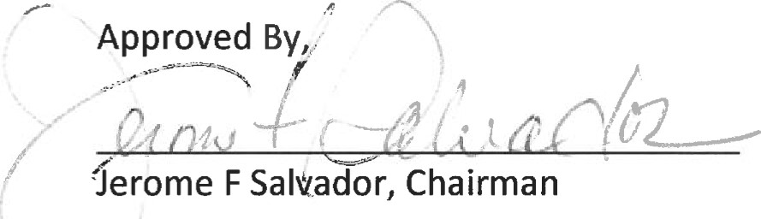

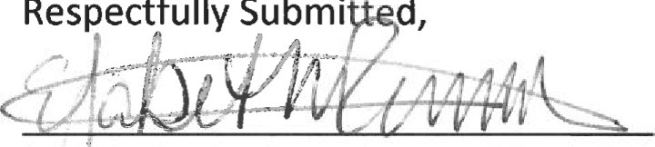

Respectfully

Submi

d,