MINUTES OF THE MEETING OF THE

TRANQUILLITY IRRIGATION DISTRICT BOARD OF DIRECTORS

November 20, 2024

PRESENT: President Jerome F Salvador, Director William Pucheu, Director George Ayerza Jr, General

Manager Danny M Wade, Assistant Manager Rodney D Wade, Counsel Lauren Layne, Engineering Consultant Joe Hopkins, & Secretary/Treasurer Liz Reeves

ABSENT: none

President Salvador called the meeting to order at 8:30 am.

ADDITIONS OR DELETIONS TO AGENDA: None

PUBLIC COMMENTS: none

MINUTES: The minutes of the meeting of October 16, 2024 was approved on voice count. Director Ayerza motioned for approval and Director Pucheu seconded the motion.

TREASURER REPORT: The Cash Flow statement was presented for the month of October 2024 including the cash disbursements and receivables. Director Pucheu motioned for approval of the Treasurer report. Director Ayerza seconded the motion.

WATERMASTER'S REPORTS: Water use — irrigation and drinking water: Assistant Manager Wade reported on the usage totals for the month of October 2024, along with the well pumping totals and the Mendota pool reporting.

The well depths along with PH/TDS readings were presented to the Board.

DIRECTOR REPORT: none

NEW BUSINESS/ACTION ITEMS:

A. Fourth Amendment of Central Delta Mendota Region SGMA Services Activity Agreement and Consent of SS-MOA Participants —was presented to the board for approval. After review Director Pucheu motioned for approval and Director Ayerza seconded the motion. Instruction was given to sign the agreement.

COUNSEL REPORT: In regards to legal matters affecting the District:

Kings River: the extension agreement was approved for the lower river units.

SGMA: there is a new coordinator for the subbasin — Chase Hurley w/John Brodie as the part time assistant. Steve Stadler is the Rep for the coordination committee. The pumping reduction plan is being worked on for us and will be compiled into one plan with the other groups. There will be a meeting with State Waterboard staff in December to go over issues with our GSP.

ENGINEERING CONSULTANT REPORT: SGMA: see counsel's report.

Projects: The meter project is almost done. We have a new foreman contact and have requested their schedule for completion so this project can be closed out by the end of the year. Well 8there is a delay with the electrical equipment and we are waiting on the pump components to come in. Once everything is ready, they will come back and finish it all at once. Well 9- we are moving forward with the design and will soon get it out to bid. We are currently waiting on PG&E.

MANAGER REPORT:

1. 2024 Water Schedule Tracking : updated report was presented.
2. 2024 Revised Schedule: a revised water rights schedule was presented.
3. SLWD — 2024 Final Payment: the final invoice has been sent. 10% of the cvp water will be rescheduled into 2025. We will have a meeting next year to discuss renewing the contract with SLWD.
4. Reservoirs -TID & FSWD: The Manning Ave 56 acres are completed and we are now working on the FSWD land reservoir. We did not receive any bids for the 137 acres on Manning so we will not be leasing out this land.
5. Fresno Slough Water District — Rights Water Transfer: 866 af of rights water will be moved into TID. P&P and Legal will help us with the paperwork.
6. DOT Federal Application: all employees using company vehicles will have to fill out a driver application on the site for us to be in compliance
7. Citation — Lead and copper monitoring: SWRCB issued the citation for not collecting the lead & copper samples on time. We will be notifying the public and samples will be collected June 2025
8. 2025 Fixed Term Employees: we have 2 seasonal part time employees that we will be converting to fixed term employees February 2025. They will be hired specifically for the reservoir project. We will talk with Legal to ensure we are in compliance.
9. TID BBQ 2024: went well

CLOSED SESSION:

1. Closed Session Pursuant to California Government Code Section 54956.8

CONFERENCE WITH REAL PROPERTY NEGOTIATORS

Property: Temporary Water Transfer

Agency Negotiator: Danny M Wade & Rodney D Wade Negotiating Parties: TID & SLWD

Under Negotiation: Price & Terms (no reportable action)

1. CONFERENCE WITH REAL PROPERTY NEGOTIATORS Pursuant to California Government Code Section 54956.8

Property: Water Rights

Agency negotiator: Danny M Wade & Rodney D Wade

Negotiating parties: Various Water Users, unspecified for the benefit of the public agency

Under negotiation: Instruction to negotiator will concern price and terms of payment (no reportable action)

1. CONFERENCE WITH REAL PROPERTY NEGOTIATORS

Government Code Section 54956.8

Property: Kings River Water Rights

Agency negotiator: Danny M Wade & Rodney D Wade

Negotiating parties: Lower River Units of the Kings River Water Association

Under negotiation: Instruction to negotiator will concern price and terms of payment for rental agreement.

(no reportable action)

1. CONFERENCE WITH LEGAL COUNSEL - EXISTING LITIGATION

Closed session pursuant to Paragraph (1) of subdivision (d) of Government Code Section 54956.9.

Name of Case: NRDC v. Jewell — U.S. District Court— Eastern District of California (Case

No. 1:05-cv-01207UO-EPG) (no reportable action)

1. CONFERENCE WITH LEGAL COUNSEL - EXISTING LITIGATION

Closed Session pursuant to Government Code Section 54956.9(d)(1) Name of Case: James Irrigation District v. KRWA, et al. (no reportable action)

1. CONFERENCE WITH LEGAL COUNSEL - POTENTIAL LITIGATION -1 case Closed Session pursuant to Government Code Section 54956.9 (d)(l) (no reportable action)
2. CONFERENCE WITH REAL PROPERTY NEGOTIATORS

Closed Session Pursuant to California Government Code Section 54956.8

Property: Fresno Slough Water District land

Agency Negotiator: Danny M Wade & Rodney D Wade

Negotiating Parties: TID & Angiola WD

Under Negotiation: Price & Terms (no reportable action)

1. CONFERENCE WITH LEGAL COUNSEL - EXISTING LITIGATION

Closed Session pursuant to California Government Code Section 54956.9(d)(1).

Name of case: California Sportfishing Protection Alliance v. All Persons

Interested in the Matter of the Validity of the Northern and Central DeltaMendota Regions Groundwater Sustainability Plan, et al., Stanislaus County

Superior Court, Case No. CV-20-001748 [Delta-Mendota Subbasin SGMA

Challenge]. (no reportable action) ii. Name of case: Center for Biological Diversity, Restore the Delta, and Planning and Conservation League v. United States Bureau of Reclamation, Tranquillity Irrigation District, et al. In the United States District Court for the Eastern

District of California, Case No. 1:20-cv-00706 DAD-EPG. (no reportable action)

1. CONFERENCE WITH LEGAL COUNSEL - EXISTING LITIGATION

Closed Session pursuant to California Government Code Section 54956.9(d)(1).

NORTH COAST RIVERS ALLIANCE, CALIFORNIA SPORTSFISHING PROTECTION ALLIANCE, PACIFIC COAST FEDERATION OF FISHERMEN'S ASSOCIATIONS, SAN FRANCISCO CRAB BOAT OWNERS ASSOCIATION, INC., and INSTITUTE FOR FISHERIES RESOURCES v.

UNITED STATES DEPARTMENT OF THE INTERIOR, et al. - United States District court,

Eastern District of California (Case No. 1:16-CV-307 DAD-SKO). (no reportable action)

Reports out of Closed Session: none

The Board adjourned at 10:35 am.

|  |  |  |
| --- | --- | --- |
|  |  |  |
| Eliza | eth Reeves, Secretary/Treasure | |

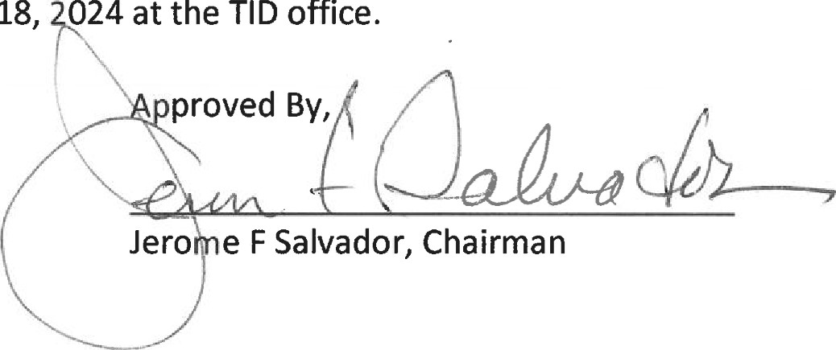The next meeting will be held at 8:30 am on December 18, 024 at the TID office.

Respectfplly Submitte